**MongoDB Lab Assignments- Day 1**

**MongoDB Exercise in mongo shell**

Connect to a running mongo instance , use a database name mongo_practice.

Document all your queries in javascript file to use a reference.

**Insert Documents:**

1. 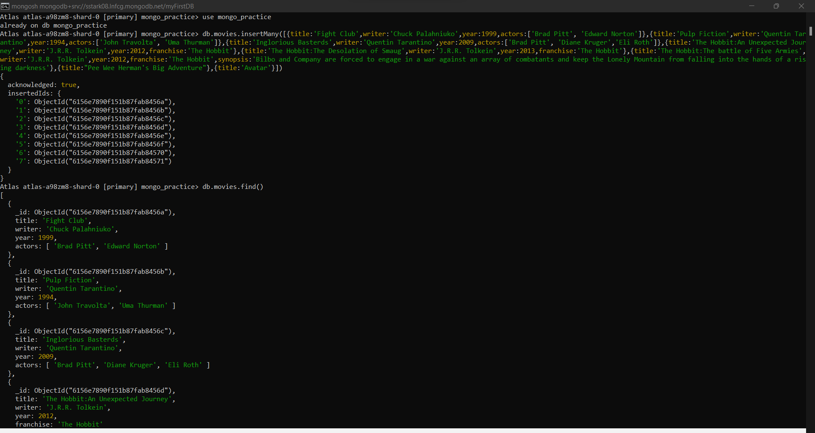Insert into movies collection:
2. Get all documents:

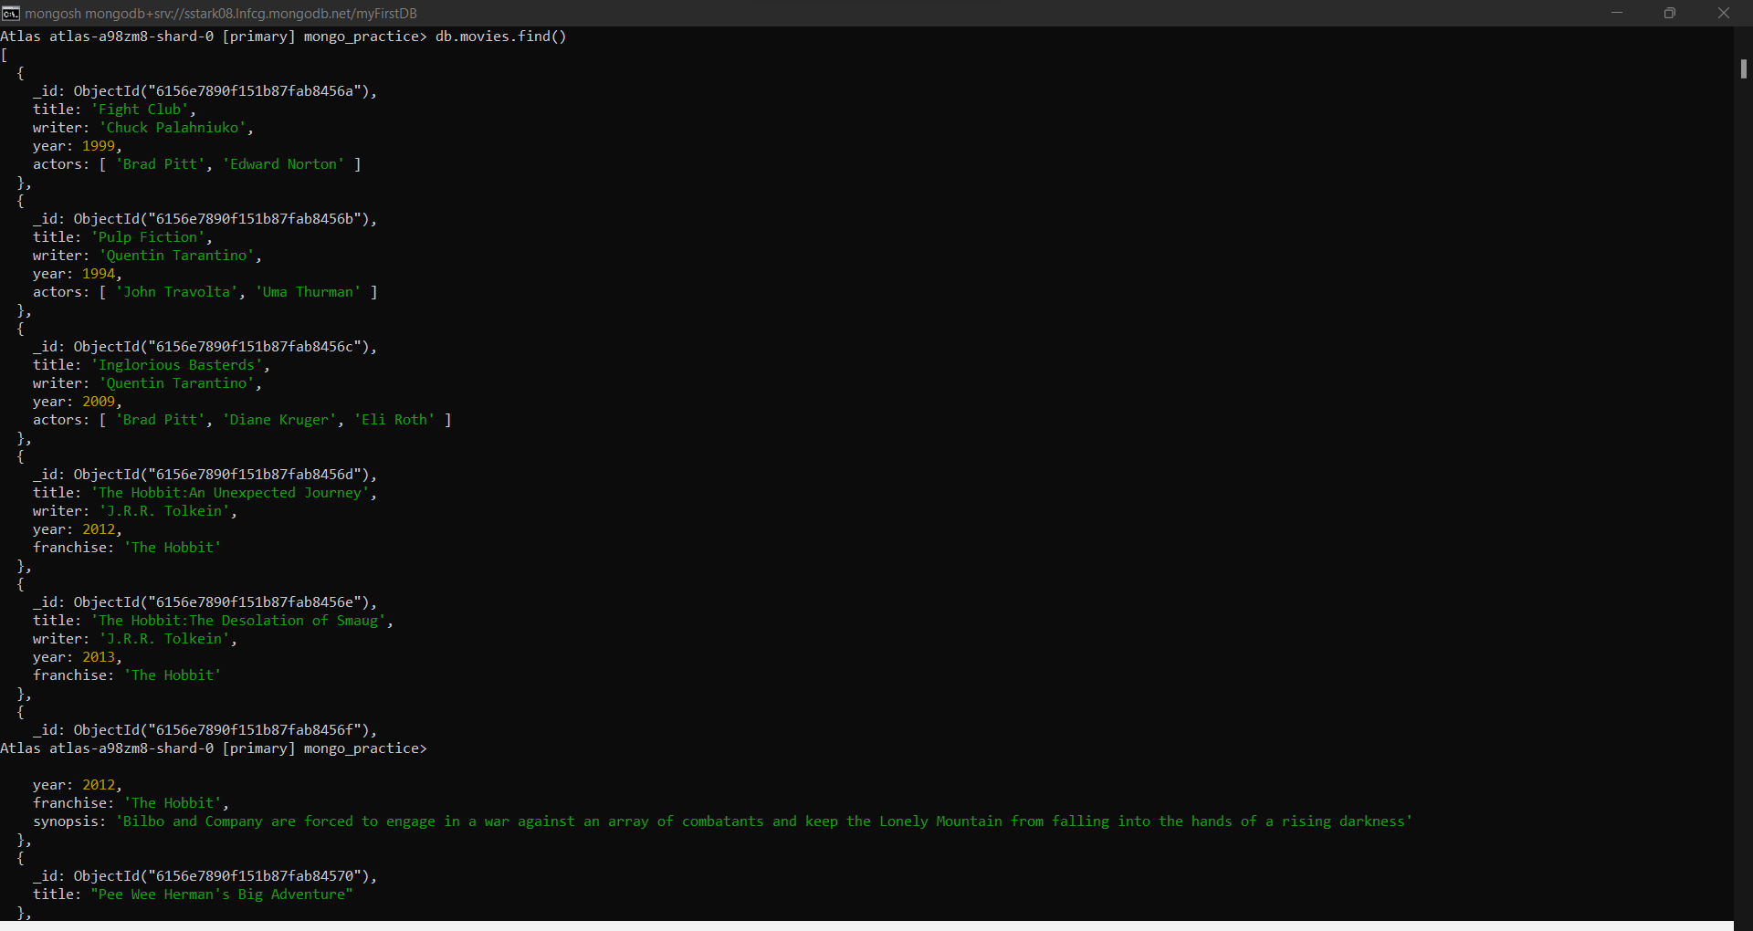

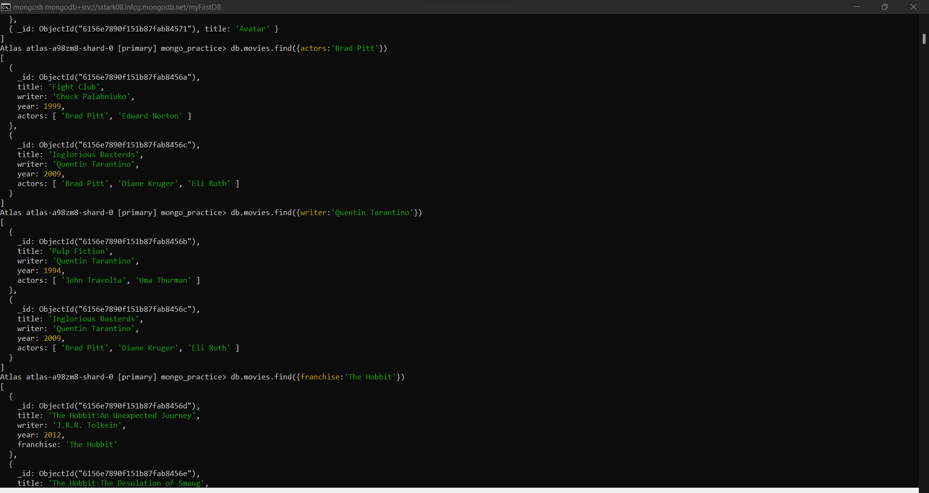

1. Get all documents with writer “Quentin Tarantino”:



1. Get all documents where actors include ‘Brad Pitt’:



1. Get all documents where franchise is ‘The Hobbit’:

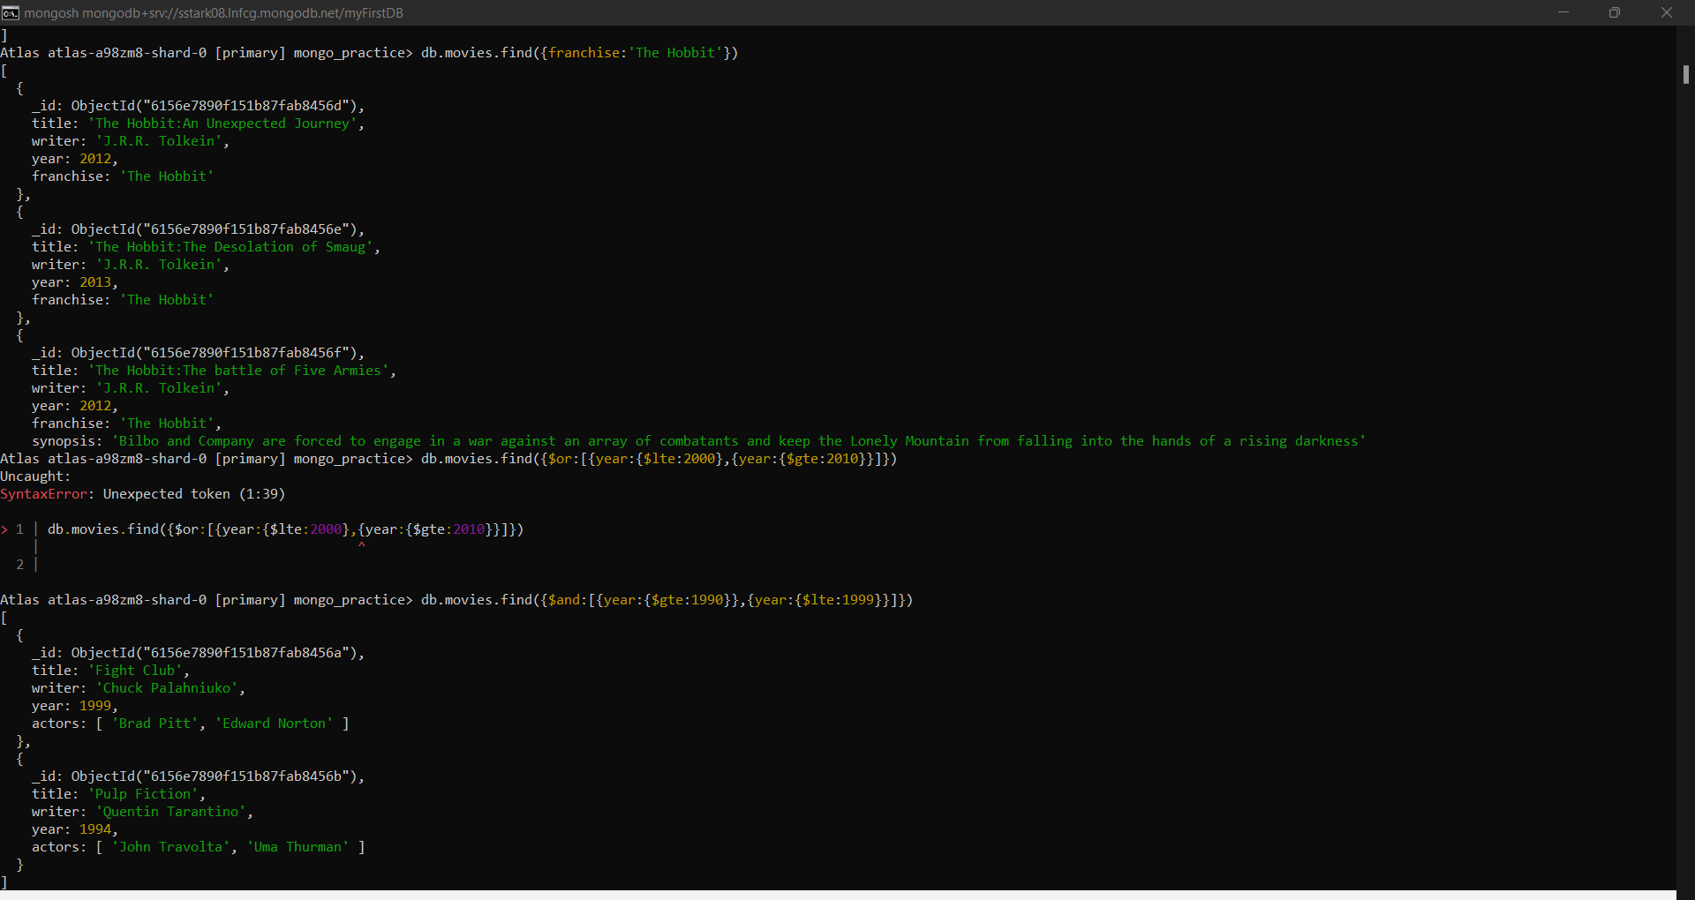

1. Get all movies released in 90s:



1. Get all movies released before year 2000 or after 2010:

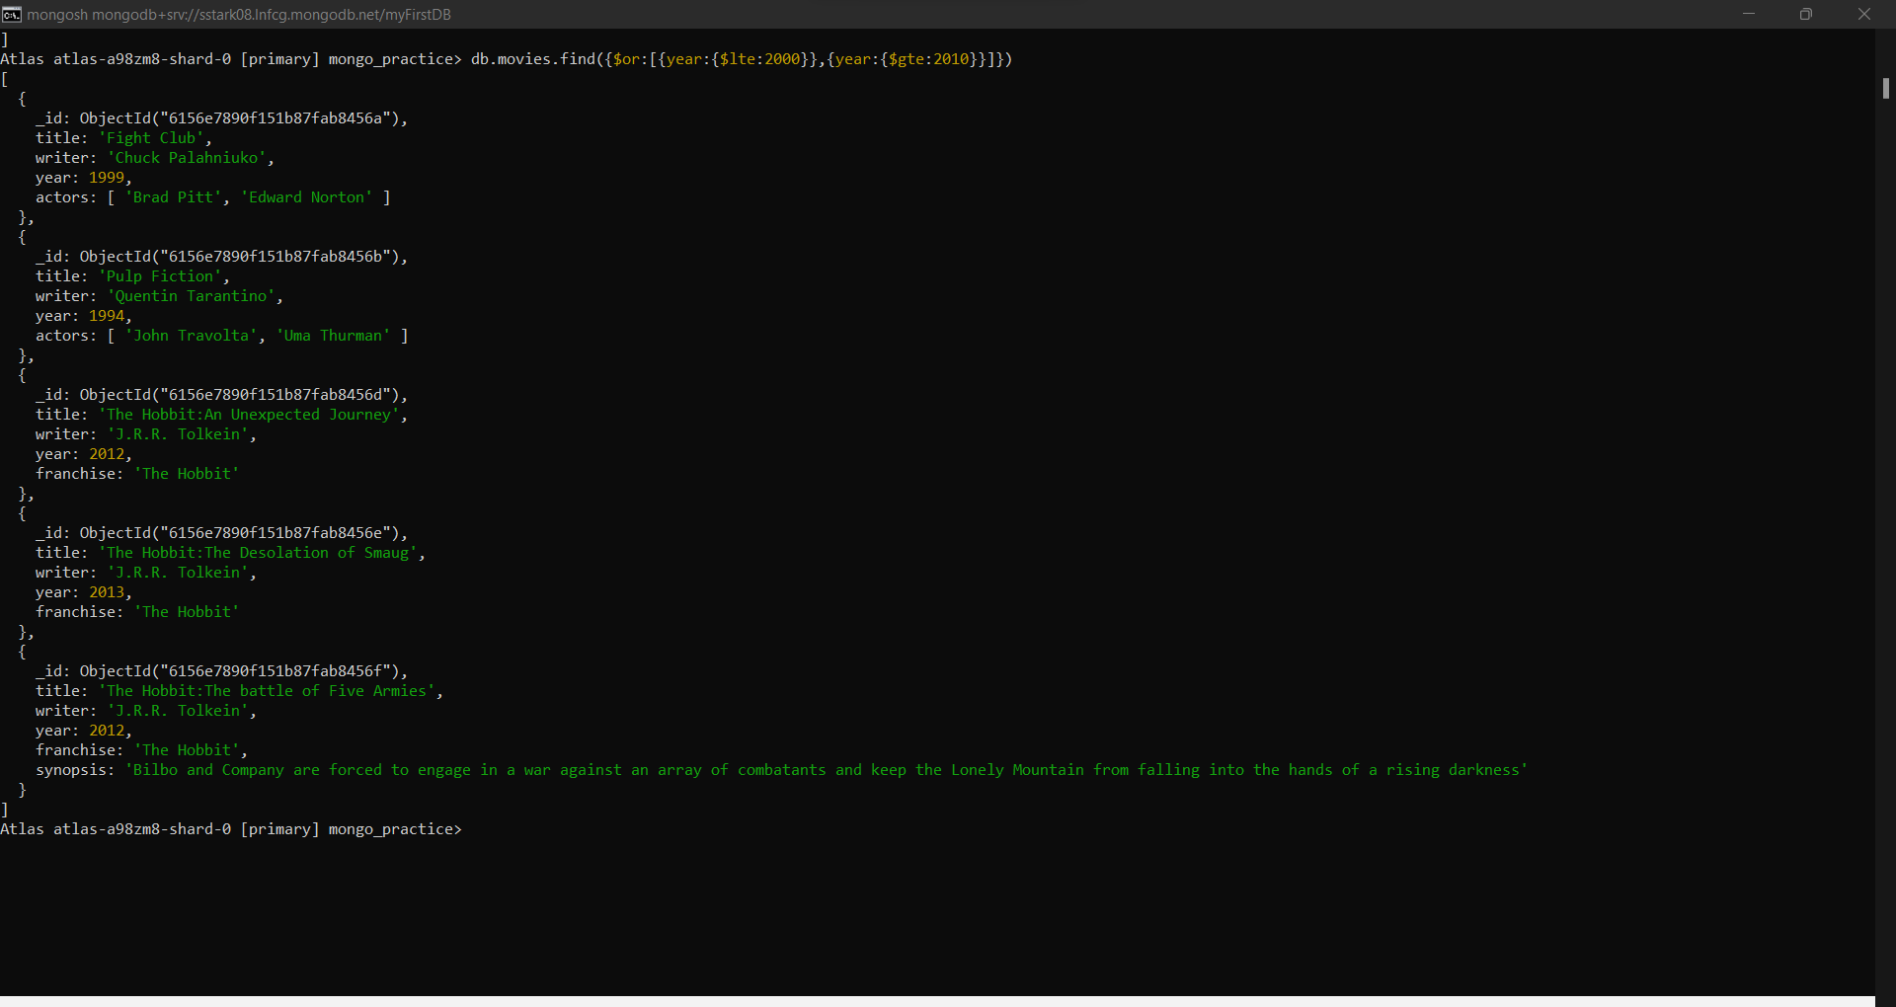

**Update Documents:**

1. 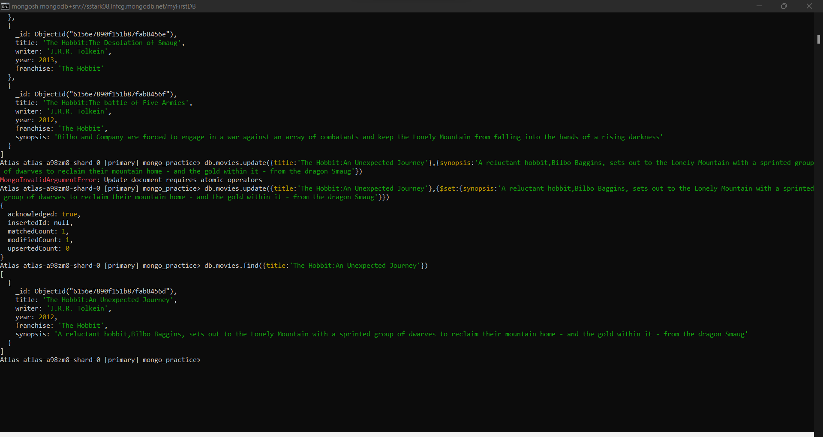Add synopsis to ‘The Hobbit:An Unexpected Journey’:
2. 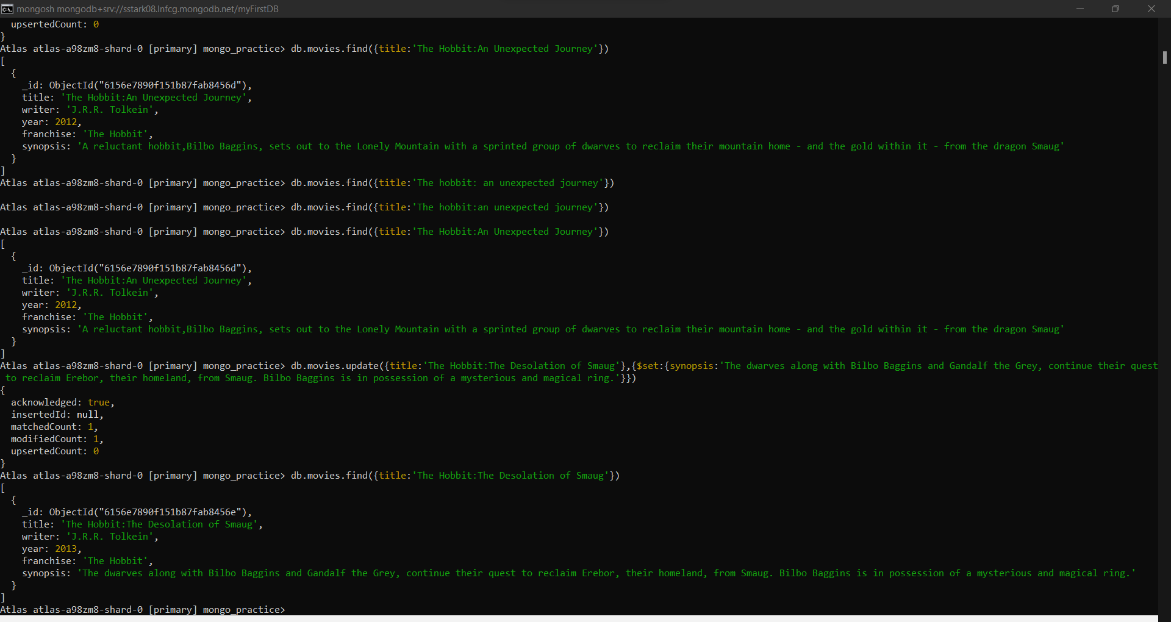Add Synopsis to ‘The Hobbit:The Desolation of Smaug’:
3. Add actor name ‘Samuel L. Jackson’ to the movie ‘Pulp Fiction’:

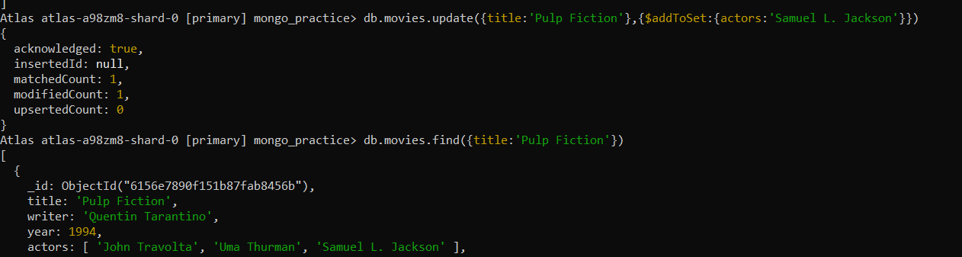

**Text Search:**

1. Find all movies that have a synopsis that contains the word ‘Bilbo’:

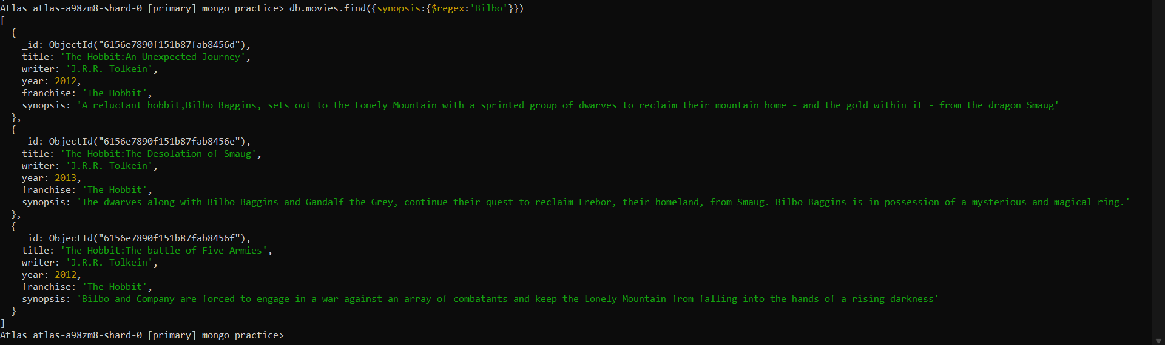

1. Find all movies that have a synopsis that contains the word ‘Gandalf’:

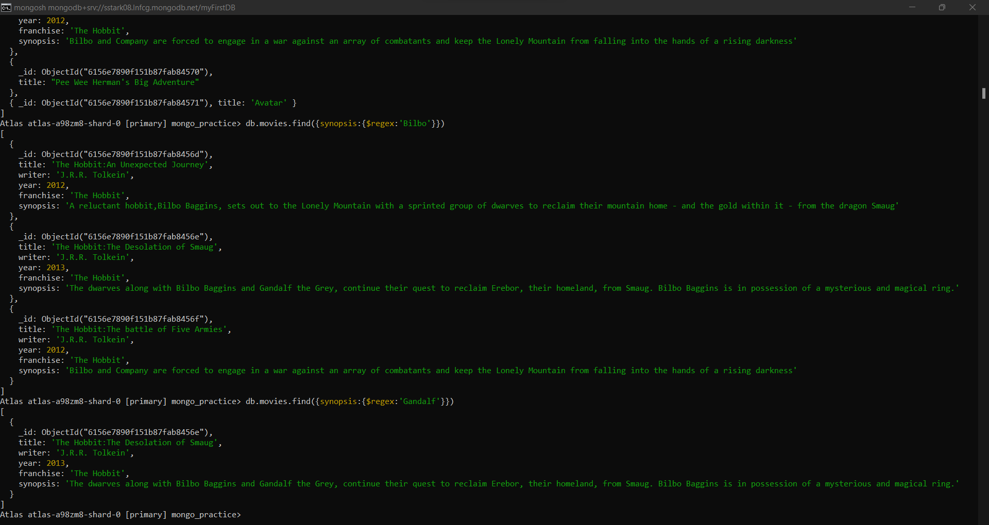

1. Find all movies that have a synopsis that contains the word ‘Bilbo’ and not the word ‘Gandalf’:

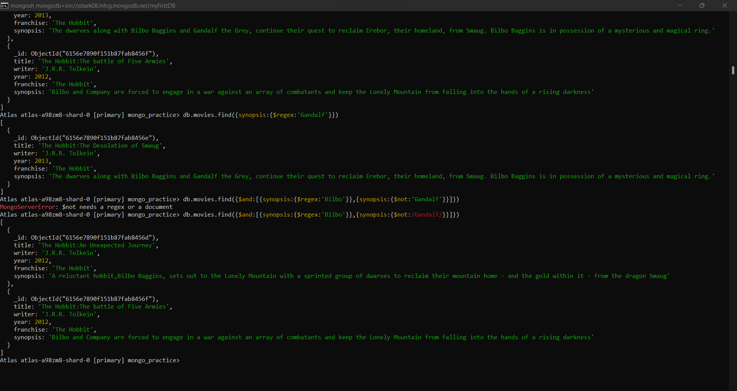

1. Find all movies that have a synopsis that contains the word ‘dwarves’ or ‘hobbit’:

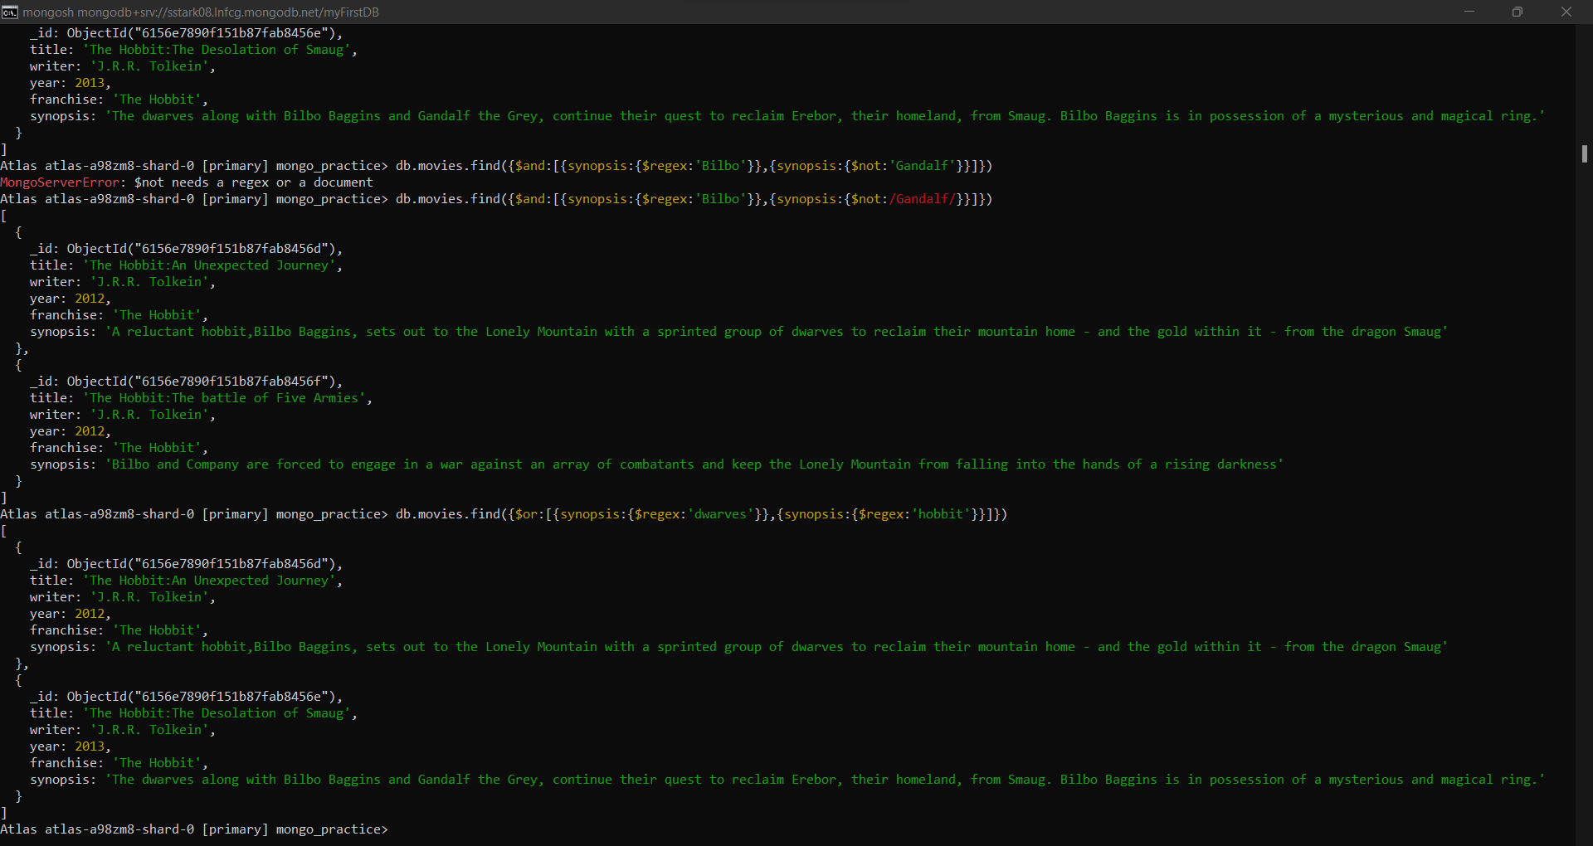

1. Find all movies that have a synopsis that contains the word ‘gold’ and ‘dragon’:

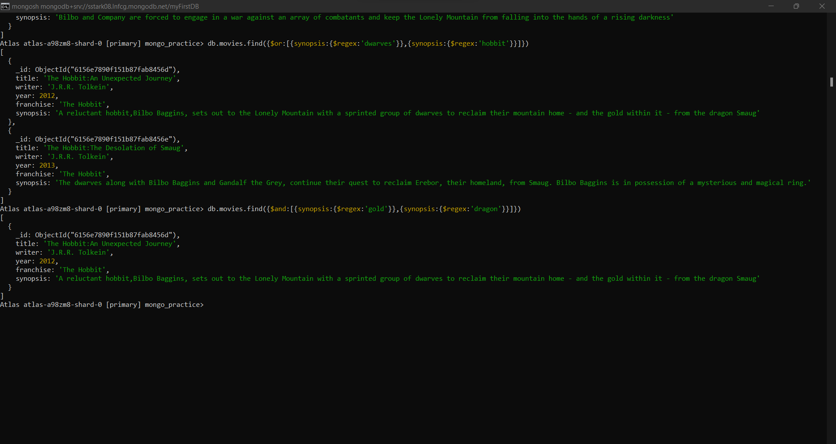

**Delete Documents:**

1. Delete Movie name ‘Pee Wee Herman’s Big Adventure’:

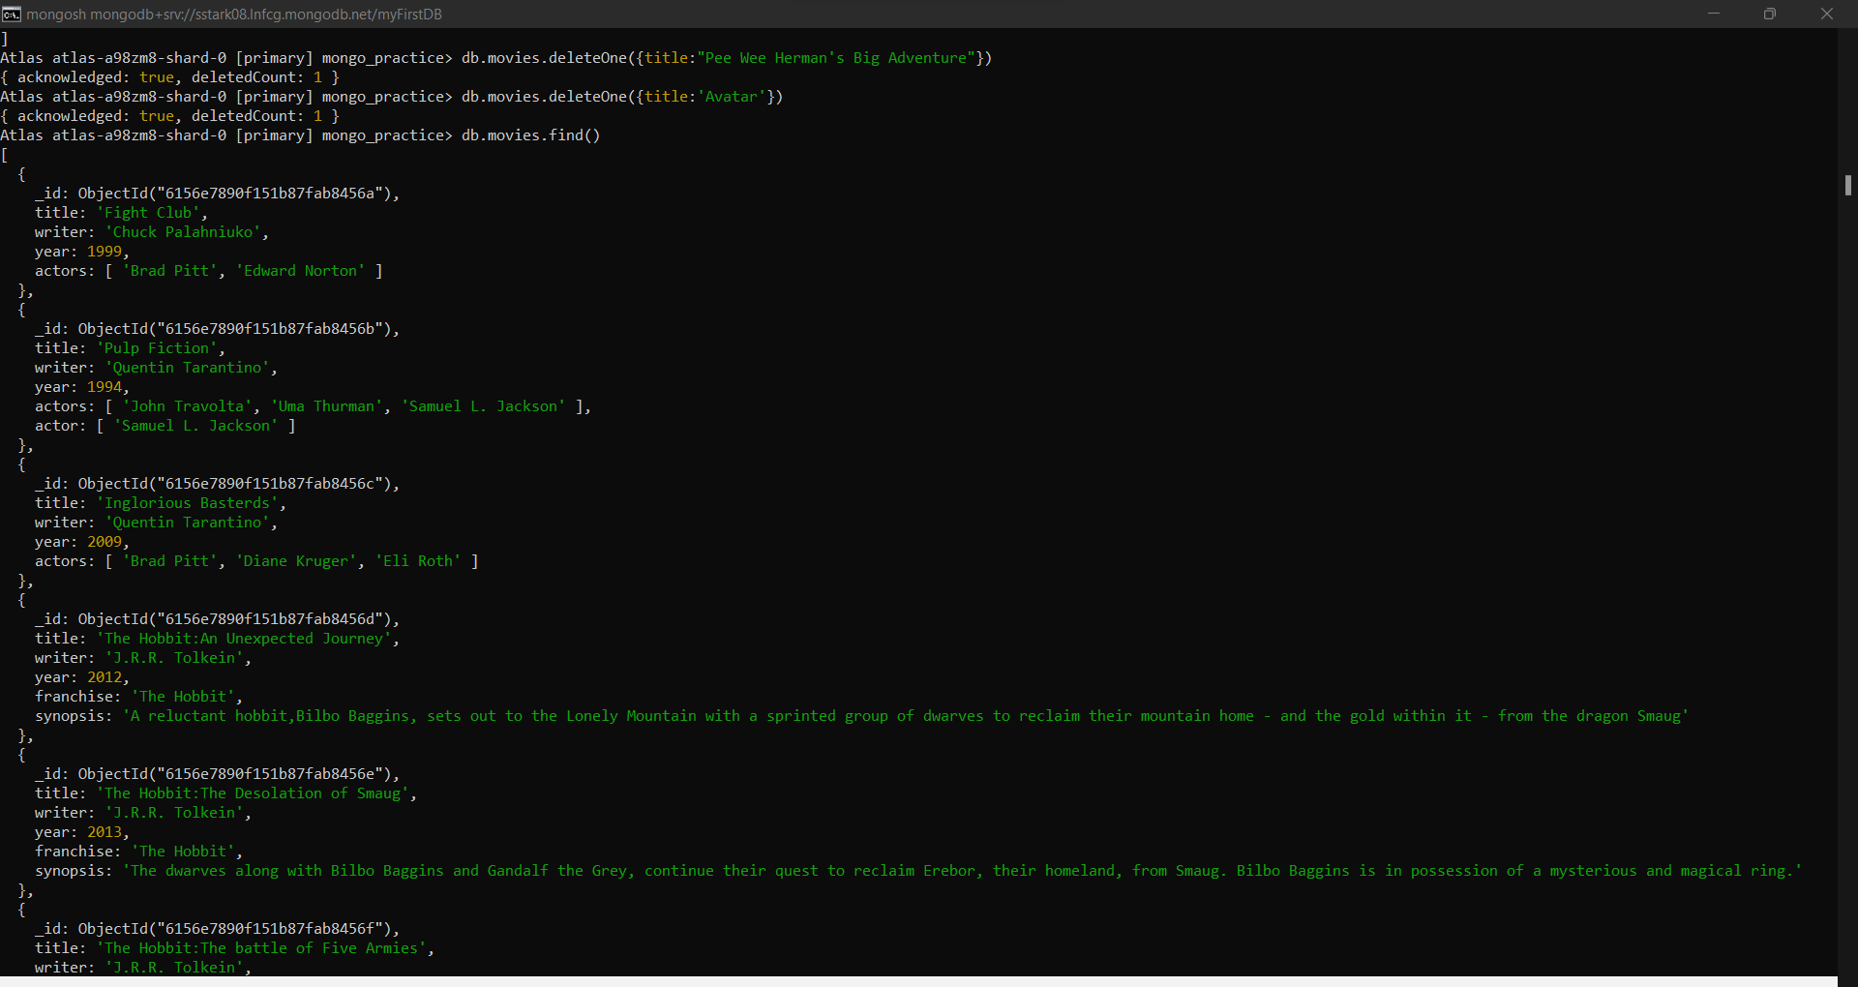

1. Delete movie name ‘Avatar’:



**Relationships:**

1. 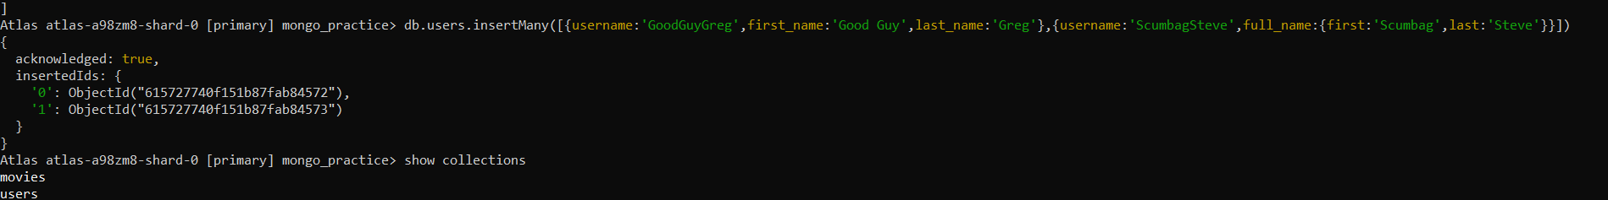Insert following documents into a users collection:
2. 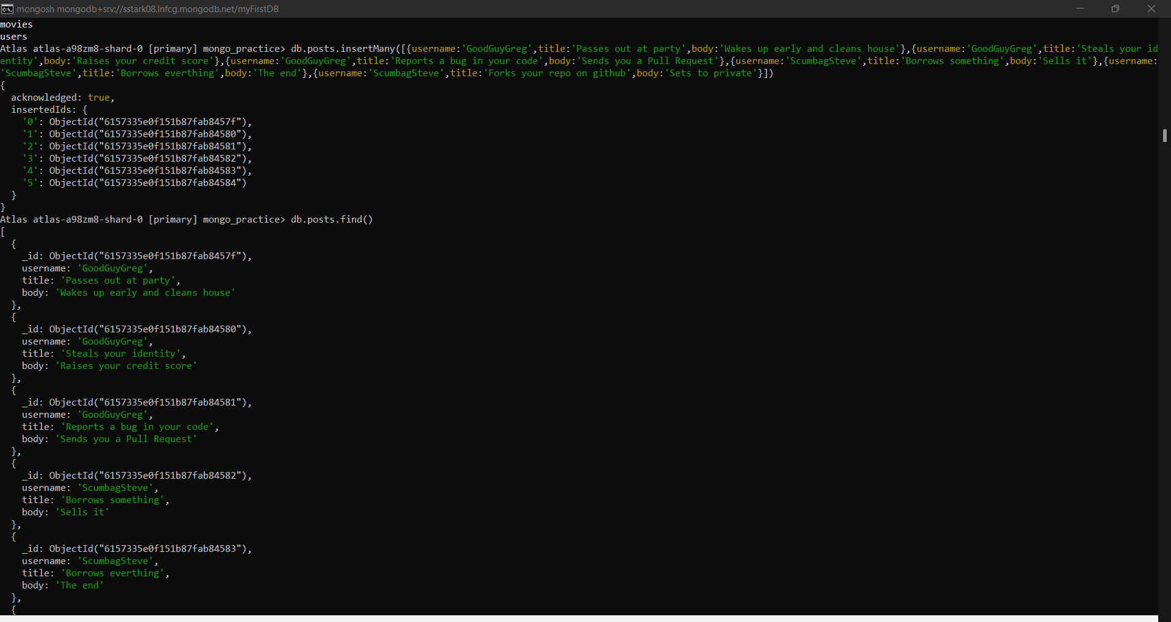Insert following documents into a posts collection:
3. 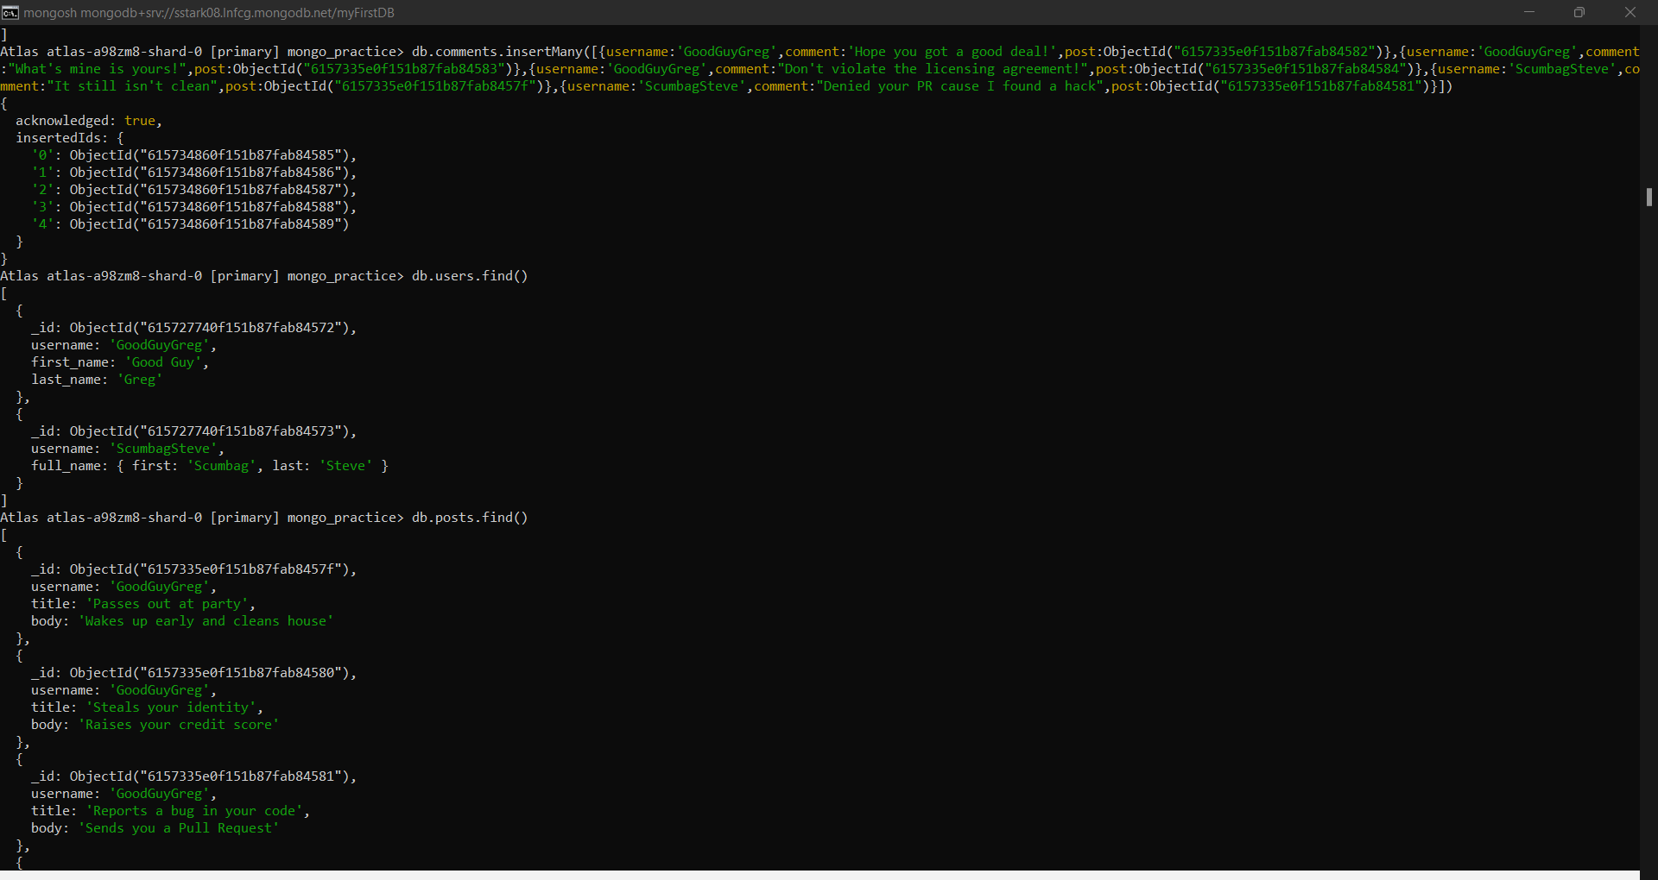Insert following documents into a comments collection:
4. Find all users:



1. 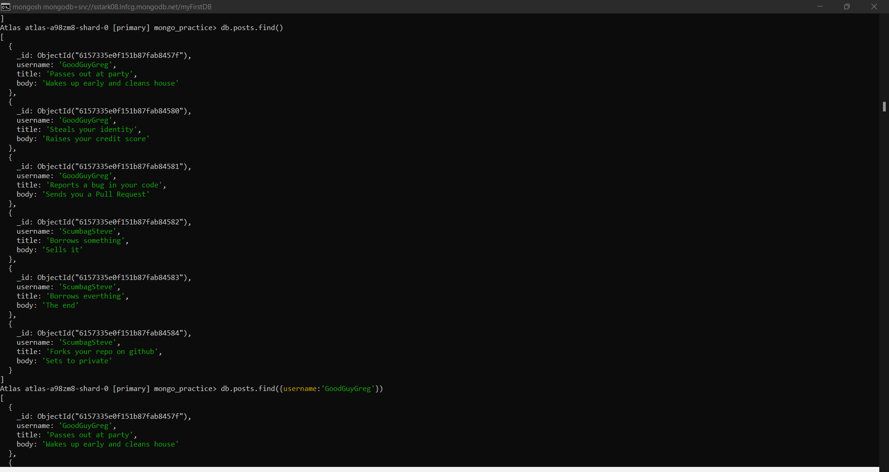Find all posts:
2. Find all posts that was authored by ‘GoodGuyGreg’:

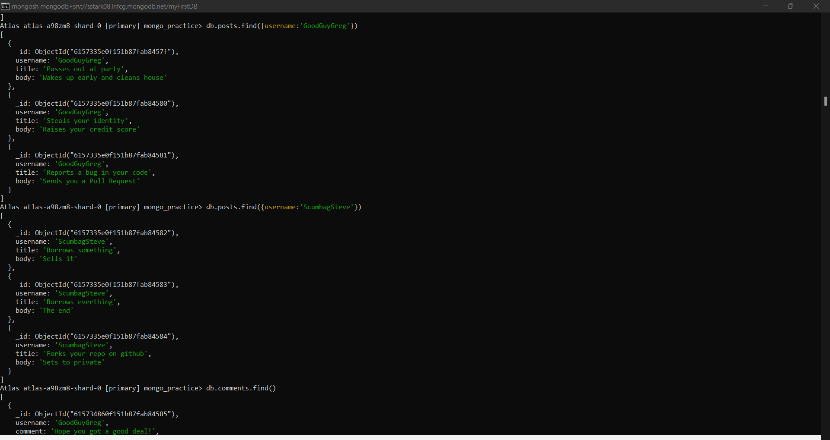

1. Find all posts that was authored by ‘ScumbagSteve’:



1. Find all comments:

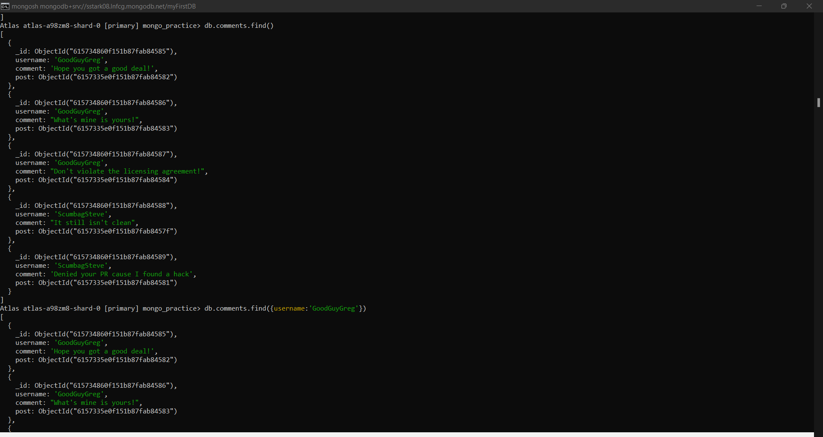

1. Find all comments that was authored by ‘GoodGuyGreg’:

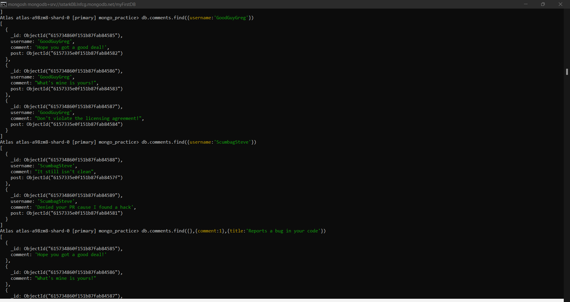

1. Find all comments that was authored by ‘ScumbagSteve’:



1. Find all comments belonging to the post ‘Reports a bug in your code’:

